ASTOR ESTEPONA – CENTRO

WELCOME & INFORMATION BOOK
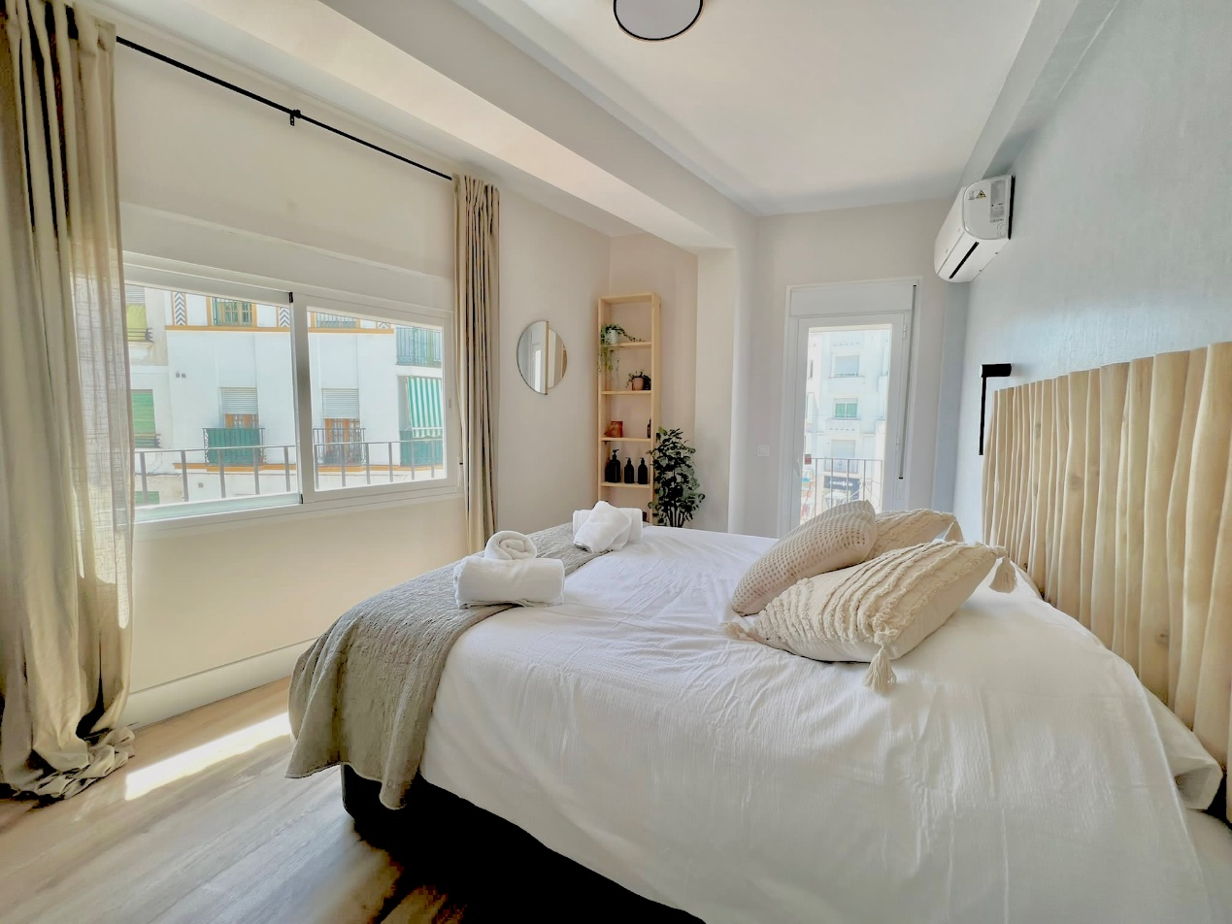
www.astorestepona.com
Dear Guest,

Please accept a warmest welcome to The Astor Centro. We hope you have an AMAZING time in beautiful Estepona. The apartment is situated right in the centre of the Old Town (just turn right out of the apartment) and all the wonderful bars and restaurants of the garden of Andalucia.

Please take your time to read all the information in this book as it contains useful information about the apartment and more importantly, information about the surrounding area.

If something isn’t right with your stay, please contact us as soon as you can and let us know and we will do our very best to help.

Warmest wishes,
David and Laura
WELCOME TO ASTOR ESTEPONA-CENTRO

If you have any questions regarding your stay
please contact us via WhatsApp:
David +44 7968796194
Laura +44 7881793347

For emergencies only contact:
Jessie Lever
Tel / WhatsApp: +34 638 233 041
Email: jessie.lever@yahoo.co.uk

Your address whilst staying with us:

WIFI
Network:
Password:

For the most up-to-date information check our website: www.astorestepona.com

CONTENTS

GENERAL INFORMATION 5
APPLIANCE INSTRUCTIONS 11
EMERGENCY NUMBERS 15
OTHER USEFUL NUMBERS 16
MEDICAL ASSISTANCE 18
DEPARTURE CHECKLIST 21
PLACES TO VISIT AND THINGS TO DO 22
BARS AND RESTAURANTS 32
DAY TRIPS 35
MAPS 43

GENERAL INFORMATION

Welcome to the Astor Estepona. We are delighted you have chosen to spend your holiday with us and sincerely hope you will enjoy your time in Spain.

CHECK IN & OUT
Check in is from 4pm and check out is 10am. If you would like a late check out please contact us using the details in this book and we will do our best to accommodate any requests. Please empty all bins (in the skips outside the Super Pozo Supermarket) and ensure the dishwasher is empty on vacating the apartment. When you leave the apartment at check out please lock the apartment door and leave the keys in the black safe

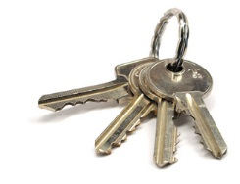
KEYS
You have two sets of keys that open the apartment door. The communal door to the flats is operated by a keypad. The keypad number is . The black safe in the downstairs hall belongs to us. The code is . Please look after the keys as any loss will be deducted from your deposit.

The front door works on a code and should never be locked. If you ever find it to be locked please contact us immediately. There is a key to the communal front door in the ‘break to open’ box situated above the apartment door / electric box within the apartment which can be used in an emergency only.

HOUSE RULES
Please be mindful of the amount of noise you make, especially during the evenings. The Astor Estepona is strictly no smoking. Please be aware that additional cleaning charges will be deducted from your deposit should this occur. Whilst in the apartment please make sure that the main apartment door is locked at all times. When you leave all doors should be locked, including those accessing the roof terrace.

AIR CON / HEATING
We have brand new air con devices throughout the apartment and will cool the apartment very quickly on entering. Please consider the environment and turn the units off when you are out and shut all external doors and windows when you are using the air con. The units can also be used as heaters in the winter. There is a remote for each unit in the respective rooms. Use the remotes to turn on/off and change settings. To switch on the air con, press ‘start/stop’ then choose ‘cool’ on mode setting and set temp up and down. Or heating in the winter choose the ‘heat’ mode.

LINEN
All bed linen and bath/hand towels are provided. Please remove your make-up, sun tan lotion and any fake tan before getting into bed. Some products stain the sheets and cannot be removed. Bedspreads can be found under the double bed if required for extra warmth.

KITCHEN
The apartment has a fully fitted kitchen, including hob, electric oven, extractor, fridge with freezer compartment, dishwasher, microwave, blender, coffee machine and dishwasher. The coffee machine takes Dolce Gusto capsules. We try and keep the dishwasher topped up with salt and rinse aid but if you notice the dishwasher performing sub-par then we provide additional supplies of salt and rinse aid which can be used to top up. We also provide cleaning essentials either situated below the sink or in the left hand cupboard near the washing machine.
PARKING
There are various options for parking. As we are so central its recommended to park up and explore Estepona by foot during your stay! The best place to find on-street parking is north of the square (Plaza Antonia Guerrero) on Calle Granada / Calle de Jesus Cautivo. Spots tend to be free around 7-9am when people are leaving for work. All the on-road parking is free. There is parking available in the underground car park in Plaza Antonia Guerrero (put Calle de Zaragoza into your sat nav and access the car park from the North-West side of the square). This costs a few Euros per day for the first 2 days, after that the charge is higher. It is sometimes full but there are cars coming out frequently so usually you don’t have to wait long to get in on a one-in one-out basis. Further paid underground parking is available on the sea front accessed via Avenida de Espana which is a few minutes’ walk from the apartment.

BINS
Please ensure that all rubbish bags are taken to the bins outside the Super Pozo supermarket. This must only be done after 8pm. Due to the warm climate ants and rats will appear very quickly if refuse is not disposed of correctly.

SUPERMARKETS / SHOPPING
There are numerous supermarkets within walking distance. The nearest is Coviran Super Pozo just North of Plaza Antonia Guerrero on Calle de Valencia (opposite the Vodafone shop, walk down the ramp), marked as a red star, the apartment is the yellow sun. This has all the basics. The Dia is also very close (Calle de Juan Gris, blue face on map). If you would like more choice try the Supersol on Calle Portada (orange cross on the map) or Mercadona (green heart on map). There is a large Carrefour Hypermarket a short stoll along the seafront (yellow lightning bolt on map) – you could walk there and get a cab back! This has all the food and drink you could wish for and more, and a large clothes dept, electrics, gardeining/outdoor/ beach goods etc.

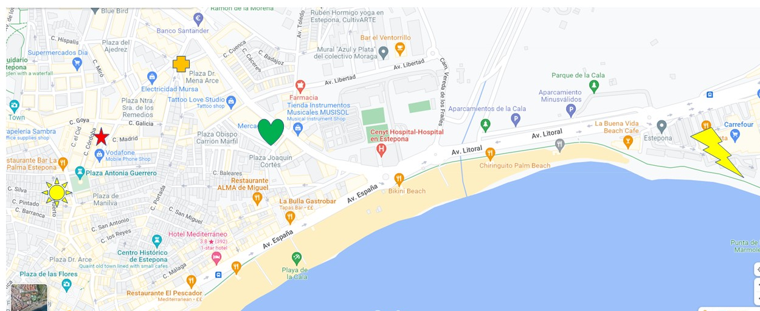

POWER
The power supply is different to some countries, and it is not unusual to experience power cuts particularly during peak holiday times. These normally don’t last longer than an hour. Please check all fuse switches are in the ‘Up’ position if the power cuts out – Board on the right by the apartment door.

WATER
It is safe to drink tap water in Spain however many don’t find the taste palatable therefore choose to drink bottled water instead.

Please note our water pressure is very good but the Spanish drainage is not! To prevent a foot bath, you can reduce the power output of the shower by turning the left hand handle on the shower.

RESTAURANTS
The Spanish tend to eat late, so traditionally restaurants usually don't open until 1.30pm for lunch and 8pm for dinner. However, in the busy summer months and tourist areas you might find restaurants remain open all day. Please see our favourite restaurants at the end of the guide.

BEACH
There is beach equipment available in the left hand cupboard next to the washing machine. Please feel free to use this; all we ask is that you throw away any broken items and return useable items in a clean state with the sand brushed off them. If you have any unwanted beach items please feel free to add to the collection when you leave for future guests to enjoy. To reach the beach walk around 300m south down Calle Terraza and you will hit the sea! You will pass Heladeria Ambrosia just before you reach the sand (next to the Correos/post office) – this is the best ice cream in Estepona! There are sun loungers and parasols that can be hired and many lovely beach bars and Chiringuitos along the beach to get refreshments. For a more sheltered beach jump in a taxi and head to Playa Del Cristo (near the port – approx. 7 euro). This is a lovely beach for children as the water is very calm and shallow. There are two beach bars on this beach and toilets / showers available in high season. Parking at Cristo beach is free and can be accessed via Avenida Luis Braille.

CHILDRENS EQUIPMENT
We have lots of equipment to make your stay as family friendly as possible. We have a travel cot and highchair under the bed in the master bedroom / next to the washing machine. Please clean these after use and return prior to leaving for use by the next guest. There is children’s tableware in the kitchen. Childrens toys can be found in the cupboard by the washing machine – if you use these please make sure they are clean and packed away in the cupboard at the end of your stay for future guests to enjoy. The child stairgate is operated by pushing down and twisting the orange knob on the left hand panel,

DRIVING / TAXIS / TRANSPORTATION
Driving and alcohol: The legal limit here is lower than the UK and is being enforced with high fines, driving bans and possible imprisonment. There is a taxi rank on Avenida de Espana and Uber is usually available. There are ‘Dott’ electric scooters scattered through Estepona. These are accessed by downloading the Dott app and can be hired by the minute. They are a great way of whizzing up and down the seafront!

WIFI
We offer FAST FREE FIBRE OPTIC WIFI during your stay.
The WIFI code is:
Network:
Password:

APPLIANCE INSTRUCTIONS

TV
We have IPTV with English Freeview channels, Sky Sports and Movies in multiple languages.

To switch on the TV:
Switch the red ‘on’ power button on the Hitachi TV remote. If the homescreen doesn’t display, press the source button and select TV. Press home button on Hitachi remote .
If you want to use your own Netflix or Youtube, you can access this via the home screen of the TV.

If you would like to use the internet TV we provide you will need to use Dreamstreams via the Android Box:
Press the ‘on’ button on the small black remote by pointing it towards the little black box above the TV. You will notice the time appear on the box in blue. Just press it once – it will take up to 20 seconds for the blue writing to appear.
Press the source button on the large black Hitachi remote twice
Choose HDMI 1 and press OK using the large black Hitachi remote
Then take the small black Android remote once again.
Toggle down and choose the icon with a circle containing 6 dots along the bottom of the screen
Choose dreamstreams.net icon and press OK
Select either ‘Live TV’ for news, sports, BBC etc
Select ‘movies’ for movies

HOB

OVEN

DISHWASHER

MICROWAVE

COFFEE MACHINE
Fill the reservoir at the back of the machine with water
Lift up top compartment (labelled ‘Dolce Gusto)
Pull out capsule drawer, insert capsule and close drawer, close compartment
Wait until you see a green light on the left of the machine
Place cup in tray, turn lever to right and hold lever to dispense
Once desired amount of coffee in cup, move lever back to centre to stop water dispensing
Only operate the machine with water in the tank otherwise it will break.

EMERGENCY NUMBERS

In case of an emergency within the apartment please call us/WhatsApp call on 0034 638 233 041

In case of general emergency (Servicios de Urgencies)
Emergency Number in English (0034) 902 102 112
Fire (0034) 080
Ambulance (0034) 061

Police (0034) 091

Local Police (0034) 092
Hospital (0034) 951 976 669
Costa del Sol

Maternity (0034) 951 030 200

OTHER USEFUL NUMBERS

From a non-Spanish phone all Spanish telephone numbers will need 0034 first

Taxis (0034) 952 802 900
Malaga Airport (0034) 952 048 804
 | Tourist Office | Police Station
Marbella | 952 77 14 42 | 952 89 99 00
San Pedro | 952 37 95 51 | 952 38 14 22
Estepona | 952 80 09 13 | 952 80 02 43
Benalmadena | 952 44 24 94 | 952 56 21 42
Fuengirola | 952 46 76 25 | 952 58 93 21
Mijas | 952 48 59 00 | 952 46 10 46
Malaga | 952 37 95 51 | 952 38 14 22

Consulate Telephone Numbers
British | 952 35 23 00
Ireland | 952 475 108
USA | 952 474 891
Canada | 952 223 346
France | 952 226 590
Finland | 952 212 435
Italy | 952 306 150
Netherlands | 952 600 261
Norway | 952 667 955
Switzerland | 952 217 266
Sweden | 952 467 195

Country Codes
To ring the UK, dial 0044 then the area code (without 0) then the number
Spain to USA 00 1 | Spain to Italy 00 39
Spain to Canada 00 1 | Spain to Finland 00 358
Spain to France 00 33 | Spain to Sweden 00 46
Spain to Germany 00 49 | Spain to Switzerland 00 41
Spain to Denmark 00 45 | Spain to Austria 00 43

MEDICAL ASSISTANCE

In the event that you should require medical attention and need to visit a hospital, general doctor, dentist or pharmacy please see the information below.

Please note if you are ringing from a UK mobile you will need to add the country code for Spain 00 34 before dialling the local number.

If you require an ambulance and urgent medical treatment, dial 061.
HOSPITAL
The nearest public hospital is the Costa del Sol Hospital; this is located on the main A-7 coast road in the direction of Malaga exit 187.

You will need to present your E111 European Health Insurance Card (EHIC) or GHIC in order to receive treatment, or a valid private travel/ health insurance.

Costa del Sol Hospital – Public
Tel: (0034) 951 97 66 69
Address: Autovia A-7, Km 187, 29603 Marbella.

If you have private travel/health insurance there are several private hospitals located very near. They will only accept private insurance and you will need to show them this first before receiving any treatment. Please check that your insurance is valid and recognised by them.

Hospiten Estepona – Private
Tel: (0034) 952 76 06 00
www.hospiten.com
Address: Carretera Nacional 340, 277, 29680 Estepona.

Cenyt Hospital Estepona – Private
Brand new Hospital in central Estepona with 24 hour A&E and over 40 Medical Specialties.
www.cenythospital.com
Tel: (0034) 952 80 81 00
Address: Avenida Andalucia 2, 29680 Estepona

FAMILY DOCTOR / GP
If you need to consult a general doctor, there are several private English-speaking GPs in the area. These will usually require immediate payment for any consultation, however many do work with the leading travel/private health insurance companies, so please check their fees first.

Dr. Peter Furness – 952 802 907 – Avenido del Carmen, Bajo G – charges approximately €90 per consultation.

PHARMACY / FARMACIA
Indicated by a green cross. Farmacia Terraza is located opposite the apartment building. There are many more pharmacies in central Estepona. Usually the pharmacist speaks reasonable English and will be able to advise you regarding any minor complaints. Spanish pharmacists often have a wider range of over the counter medicines available than other EU Countries – so worth a visit for your problem before making a GP appointment.

DENTIST
All dentists are private and you will have to pay to receive any treatment. However you may find the cost is considerably cheaper than in the UK and urgent appointments can be made quickly.

Clinica Dental Estepona
Tel: +34 952 80 67 15
Address: Calle Real, 99, 29680 Estepona,

Pearl White Dentist
Tel: +34 952 93 65 52
Address: Urb. Coto La Serena 7A, A7, km 163,5 (between San Pedro y Estepona), 29680 Estepona

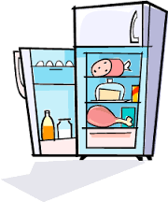
DEPARTURE CHECKLIST

Empty the fridge of all perishable items.
Dispose of all rubbish and recycling items in the bins outside the supermarket Super Pozo

Turn off all electrical equipment, air con and lights etc.

Ensure all that all crockery, pans etc. are washed and put away. Please empty the dishwasher.

Close and lock all windows and doors, including the door to the roof terrace.

An additional cleaning charge may be levied if the above items are not completed.

PLACES TO VISIT AND THINGS TO DO

Try joining the group ‘Estepona info & chat’ on Facebook – it has a wealth of information about Estepona and upcoming events etc. You can also use the search function on the page to look at recommendations for everything – from tours to tapas!

MURALS
I’m sure you have already realised but there are murals all over Estepona….over 60 of them in fact! Why not try a mural tour, you can go on an organised tour or walk your own! The tourist office has a murals map so you can do your own tour.

TAPAS TOURS
Cool events (+34697321863) run Tapas tours on a regular basis. Or make up your own! There are Tapas bars throughout the old town which you can explore and try a dish in each.

FLAMENCO

Andalusia is the home of flamenco. Cool events (+34697321863) can arrange a Flamenco evening, or you can try Pena Flamenco (A Flamenco school that often puts on events and shows – or why not have a Flamenco lesson?!, Calle Fuerzas Armadas – drop in to find out schedule of events). Alternative venues include Mi Caseta Noche Flamenca or Flamenco Marbella which are more commercial ventures and priced more steeply accordingly!

ORCHIDARIUM
Discover a stunning collection of orchids and other exotic plants in this beautifully designed botanical garden.
BEACH
Playa La Rada runs along the entire seafront and is around 300m from the apartment. The sea is cool and refreshing! There are plenty of sunloungers and parasols that can be hired. In the summer months there is usually a little funfair / trampolines etc along the beach for the kids. There are numerous beach bars along Rada beach, many of these have Bali Beds that can be hired. Our favourites are Bikini Beach, Central Beach (good happy hour!) and Chiringuito Paco. If you walk along the seafront promenade in the direction of the port, there are lots of childrens play areas and adult outdoor gyms free to use for the public. There are showers and public toilets available along the beach. Playa La Rada attracts a breeze so great for hotter days.

If you are with little children or on a breezy day when you need shelter, walk past the port to Playa Del Cristo. This is a smaller, sheltered beach with very calm water, perfect for paddling, snorkelling and stand up paddleboarding. Its about 30 mins walk from the centre of Estepona or about 7 Euro in a cab. There are public toilets and showers and two nice beach bars which often have live music for the (spectacular) sunset.

WATERSPORTS / STAND UP PADDLEBOARDING
You can hire stand up paddleboards on Del Cristo Beach during the summer. SUP and Kayak hire can also be arranged via Costa Bikes on Avenida de Espana, 10 mins walk from the apartment (https://www.costa.bike/sups/ +34 952 806 120 English spoken)

BIKE / SCOOTER / MOBILITY SCOOTERS
Single speed, road, mountain and electric bikes can be hired from Costa Bikes. They also provide electric cars which are great fun for the kids on the promenade and are suitable from 18 months as can be radio controlled. Electric scooters and mobility scooters can also be hired here (www.costa.bike, Plaza ABC 2 just off Avenida de Espana on the sea front, 10 mins walk, +34 952 806 120 English spoken)

PLAYPARKS
There are several playparks in Estepona. The best of these is on the seafront / promenade on Avenida de Espana just before the roundabout with Avenida de Juan Carlos I. There are three parks here catering for toddlers to older children. There is also an adults gym on the beach further towards the Marina.

SHOPPING CENTRES
The three main shopping centres along the Costa del Sol are large and modern and have a large wide variety of different types of shops, including hypermarkets, cafés, restaurants, amusement arcade, cinemas and ten pin bowling.

They also have the added advantage that you can find everything you need under one roof and if you are unfamiliar with the Spanish language you can walk about freely and you do not require a phrase book.

All of the shopping centres provide large free car parking and the opening times are normally 10.00 – 22.00 Monday to Saturday and they remain open at lunchtime.

La Canada
Marbella
(Mega Bowl - Ten Pin Bowling Alley)

Parque Miramar
Fuengirola
(Cinema showing original English films)

Plaza Mayor, Near Malaga Airport
(Cinema showing original English films)

MARKETS
Markets are a common sight in towns and villages and are an essential part of Spanish life, largely unaffected by competition from supermarkets and hypermarkets. They are colourful, noisy and entertaining and an experience not to be missed, whether you plan to buy anything or not. A variety of goods are commonly sold in markets, including food, flowers, plants, clothes, shoes, ironmongery, crockery, hardware, linen, ceramics, cassettes, carpets, and leather goods. Markets usually operate from 9.00 am until 14.00 pm

Market Days:
Wednesday
Estepona (Avenida Reina Sofia, near Parque las Mesas)

Friday
Benalmadena - by Tivoli World and Plaza San Pedro

Saturday
La Cala de Mijas
Nueva Andalucía - Centro Plaza Shopping Centre and Bullring opposite
Fuengirola - Car boot sale in the fairground

Sunday
Arroyo de la Miel - At Tivoli World
Sabanillas
Estepona Marina

WATER PARKS
The Costa del Sol has several fantastic water parks that cater to visitors of all ages. Here's some information about the prominent water parks in the region:

Aqualand Torremolinos:
Location: Located in the heart of Torremolinos, Aqualand is one of the oldest and most renowned water parks on the Costa del Sol.
Attractions: Aqualand offers a wide range of water attractions, including numerous water slides, wave pools, lazy rivers, and children's play areas. The Kamikaze slide, Boomerang slide, and Rapids are among the park's popular rides.
Facilities: The park has various restaurants, picnic areas, and shops to make your visit enjoyable and convenient.

Aquavelis Water Park:
Location: Situated in Torre del Mar, a short drive from the city of Malaga, Aquavelis is a family-friendly water park.
Attractions: Aquavelis features exciting water slides, a children's pool, a lazy river, and a wave pool. The Black Hole slide is a favorite among thrill-seekers.
Facilities: The park offers dining options, sun loungers, and shaded areas for relaxation.

Mijas Water Park (Parque Acuático Mijas):
Location: Found in the charming town of Mijas Costa, this water park is easily accessible from popular coastal towns like Fuengirola and Marbella.
Attractions: Mijas Water Park boasts a variety of slides, including the Kamikaze, Labyrinth, and Wave Pool. There are also dedicated areas for younger children.
Facilities: The park has restaurants, picnic areas, and ample space for sunbathing.

Bahía Park Algeciras:
Location: Located in Algeciras, on the western end of the Costa del Sol near Gibraltar, Bahía Park is another option for water park fun.
Attractions: This park features slides, a lazy river, a wave pool, and a dedicated area for younger visitors.
Facilities: Bahía Park has cafeterias and picnic areas for a leisurely day out.

Costa Water Park:
Location: If you're in Marbella, you can visit Costa Water Park, a unique inflatable water park located right off the beach.
Attractions: Costa Water Park offers inflatable obstacle courses, slides, and trampolines in the sea. It's a fantastic option for both kids and adults.
Facilities: You'll find facilities on the beach, including sunbeds and a beach bar.

Before planning your visit to any of these water parks, make sure to check their official websites or contact them directly for the most up-to-date information on opening hours, ticket prices, and any special safety guidelines or restrictions in place, especially considering any changes due to the ongoing global health situation. Enjoy your time splashing and sliding at the water parks of the Costa del Sol!

Fun Beach Park Estepona
Playa De La Rada in Estepona has a giant inflatable ‘aqua fun park’ in the sea during the summer months – great fun for older kids! Find them on Facebook https://www.facebook.com/Funbeachpark/

CINEMAS
Marbella, has a few cinemas that screens English-speaking films, particularly major Hollywood releases. However, it's important to note that film schedules can change, and availability may vary. To find the most up-to-date information on English-speaking films and showtimes in Marbella, consider checking the following cinemas:
Cines Teatro Goya:
Location: Cines Teatro Goya is located in Puerto Banús, Marbella.
Information: This cinema occasionally screens English-language movies, especially popular blockbusters. They may have dedicated showtimes for films in their original language (usually with Spanish subtitles).
Website: You can check their website or contact them directly for the latest film listings and showtimes.

Cinesa La Cañada:
Location: Cinesa La Cañada is situated in the La Cañada Shopping Centre, which is just a short drive from central Marbella.
Information: This multiplex cinema occasionally screens English-language films as well. They typically offer movies in their original language with Spanish subtitles.
Website: Check their official website or contact them for current listings.

Multicines Gran Marbella:
Location: Multicines Gran Marbella is centrally located in Marbella.
Information: This cinema occasionally screens English-language films and may have showtimes for films in their original language with Spanish subtitles.
Website: You can visit their website or get in touch for the latest movie schedules

OTHER ATTRACTIONS
There is so much to see and do it is not possible to cover everything, however we have listed just a few more places that we love, especially if you have children.
It’s worth using the search function on the Facebook page ‘Estepona info & chat’ which has lots of up to date suggestions of things to do.

Bloqueria Play & Build Lego centre
Central Estepona old town – children can be left for sessions if required. Make sure you take socks! Calle Zaragoza 24, Estepona
www.bloqueria.com

Adventura Amazonia Marbella - Tree Top Adventure
www.aventura-amazonia.com

Selwo Aventura Estepona – Zoo with Zebras, Lions, Elephants etc
Free for under 3’s
www.selwo.es

Superjump Estepona Trampoline Park – situated in Estepona Industrial Estate
www.superjumpestepona.com

Canyoning - Great adventure activity, travel through canyons in the foothills of the mountains of Benahavis, Marbella.
www.canyoningbenahavis.com

Rangers Safari - Jeep Safari, explore The Real Andalucía
www.rangerssafaritours.com

Sail and power charters
Dolphin watching trips and boat tours from Estepona marina
Sailandpowercharters.es
+34644053656

For a higher chance of seeing dolphins then consider travelling further afield and departing from Gibraltar or Tarifa

BARS AND RESTAURANTS

Here are some of our favourites. Please let us know of any other gems you find!

Beach Clubs and Chiringuitos
Chiringuito Palm Beach is the most well known ‘beach bar’ in Estepona, on Rada beach as you walk towards Carrefour. Recently renovated, the beach club is a true Estepona ‘classic’ serving a range of International food at reasonable prices.
Bikini Beach Bar – located at the large roundabout at the end of Avenida Espana. Has Bali Beds for hire and live music on Sundays. A fun but relaxed vibe.
Chiringuito Paco – A new kid on the block. Beautiful fresh fish and seafood eaten with your toes in the sand. Excellent service.
Central Beach – Great happy hour!
Trocadero Estepona Restaurant – just past Carrefour, brand new Adults only beach bar with access to the beach and a pool. Quite expensive (more like Marbella prices) with stunning venue – sunbeds 40 euro per day – perhaps worth it for a special occasion or for those Instagram worthy shots and if you love killer sushi……

On Del Cristo beach there are two great Chiringuitos, Havana Beach and Lolailo. You can chill out watching the sun set, have a few drinks. They also serve food so you really have no reason to move! Lolailo usually has live music in the afternoon / early evening whilst you enjoy the sunset.

Bars and Restaurants

The Astor Estepona Centro is located in the Epicentre of the old town, and you have literally HUNDREDS of bars and restaurants within a few minutes walk. Here are some of our favourites……

Old Town:
Taberna Miguel: Traditional Spanish, great steaks! Calle Caridad, 30.
La Manduca: No frills tapas on the square opposite the apartment. Good for a quick meal at (virtually) any hour. Don’t miss the freshly squeezed Zumo de Naranja! Plaza Antonia Guerrero.
Heladeria Ambrosia: The best ice cream in Estepona, in every flavour imaginable! Next to Ale-Hop on the beach front.
Darcy’s Restaurant: Lovely Tapas bar, gourmet cheese and meats. Calle de San Antonio.
Arroz Bar. Cheap and cheerful Chinese in the Old Town. Calle Los Reyes.
Pizzería Da Merco: Eat in, take out or delivery pizza. Plazoleta Ortiz.
Restaurante La Casa del Rey: The best tapas in Estepona, hangout of the coolest kids in town. Calle Raphael, 7. Book in advance as usually fully booked.
La Esquina del Arte: Gorgeous tapas in very relaxed surroundings. Good value lunch menu. Calle Villa, 8.
Restaurante El Pescador: Unbelievable seafood and paella. Av. España, 1
Sabores Gourmet: A little family run restaurant on the main street. Does a fantastic ‘Menu Del Dia’ for 12 Euro – small selection and simple food but beautiful fresh fish and great steak. Sit overlooking the beach or on the pedestrianised main street. Avenida Espana 168.
El Galeon: A lovely quirky little restaurant very near to Sabores Gourmet. The owner catches the fish in his day job as a fisherman.
Hotel El Pilar: Brand new Hotel in the Centre of Estepona overlooking Plaza Del Flores. The rooftop bar is fab for cocktails with a view. Sushi served on the terraces. The pinchos bar on the right hand alley as you look at the hotel serves free pinxos when you buy a drink.
La Cocina, Calle Blas Ortega. Great Paella and seafood in a lovely Old Town setting.
MaduBar Fusion. Plaza Dr Arce. Just a few steps from the apartment, this new fusion restaurant offers fabulous brunches and all-day dining with vegan and veggie options in a lovely setting of an old town square.

Marina:

The Marina is a 30 minute stroll down the boardwalk to the West of Estepona. The area has a much more International feel and there are lots of restaurants worth a try there.
Rosatti’s Italian Restaurante: Great food, great views over the Marina. Its upstairs.
Cafe - Bar Reinaldo: Great for a drink, always busy. They also do simple food for a quick snack. On the left as you enter the Marina through the main entrance.
Pato de Pekin: Fantastic Chinese food and great value. Downstairs, towards the far right of the Marina.
La Escollera: Locals favourite. Situated in the heart of the working port. Super fresh fish. This place is always packed so get there early! Walk down to the marina and then left towards Estepona town, this place is just near the entrance to the boardwalk in the working part of the port.
Petit Paris: Highly recommended for a ‘special’ experience. Typical French cuisine.
Tapa Thai: Authentic Thai Cuisine which is recommended by many guests.
Plan B; Great service. International dishes. A sun trap in the afternoon! Ribs highly recommended if you are a meat lover.
La Taberno del Puerto: One of the few tapas bars on the Marina if you fancy a bit of Andalucian cooking!
Knahia: Not quite on the port but a short stroll away. Delicious Japanese / sushi and cocktails.

Further afield:
Restaurante El Higuerón: This place is sensational. You need a car to get there but they do have suckling pig and lamb! Phone in advance to get a table. Carretera Benalmádena a Mijas, Km 3.1, 29640 Fuengirola, Málaga. Tel: +34 952 119 163.

DAY TRIPS

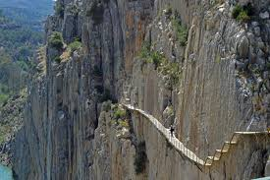
CAMINITO DEL REY - El Chorro Ardales
Approximately 1 hour by car

El Caminito del Rey is a walkway, pinned along the steep walls of a narrow gorge in El Chorro, near Ardales in the province of Malaga, Spain. The name is often shortened to Camino del Rey.

Please see their website for more detailed information and booking is essential.
www.caminitodelrey.info

BENAHAVIS
Approximately 20 minutes by car
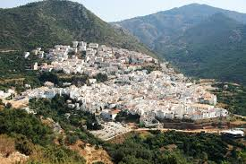
Take the A7 towards Estepona and exit at Benahavis. The road is one continuous road approximately 7kms into the mountainous village.

Benahavis is a quaint, whitewashed village with narrow streets offering many shops and bars and is famous for having the highest concentration of high-class restaurants in the region.
PERSONAL RECOMMENDATION: Los Abanicos – Benahavis: If you like to eat traditionally when on holiday this is a must, typical Spanish menu at its best, you must try the Leg of Lamb or Suckling Pig. No need to book, you may have to enjoy a jug of Sangria whilst waiting for your table, it’s all part of the experience!

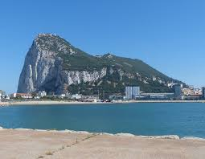
GIBRALTAR
Approximately 40 minutes by car

Take the AP7 (toll road) towards Algeciras/Cadiz. Follow the signs for La Linea and continue along the coast towards Gibraltar.

You are advised to park your car on the Spanish side of the boarder and walk across. The walk into the centre is approximately 10-15 minutes and buses are available. However, if you wish to drive, look for the parking signs and high rise multi storey car parks.

Once across the border you will find a host of guides that can take you on tours of the 'Rock', which normally includes a drive up to the top of the mountain to encounter the Barbary apes. There is also St. Michael's cave where you can see beautiful rock formations.

There are numerous shops located along the High Street and they are tax-free and offer great prices for Jewellery and perfume.

Please be aware that there are customs when re-entering Spain. There are limits to the amount of tobacco/cigarettes and alcohol you are allowed to bring back into Spain. The Spanish border Police are very strict and often carry out rigorous searches.

Remember you will need your passport and the currency is GBP.

GRANADA
Approximately 2 hours by car

Take either the A7 or AP7 towards Malaga, following the signs to GRANADA.

Granada is one of Spain's crowning glories. Its attractions range from the stately Cathedral and the remarkable building of the university quarter to fashionable streets and traditional tapas restaurants. A visit would not be complete without a visit the famous Alhambra palace with its Moorish architecture. If you wish to visit the Alhambra, you must book this in advance as tickets are strictly limited each day and sell out very quickly.

The backdrop to the city of Granada is spectacular with the snowy mountain peaks of Sierra Nevada. The skiing season starts in November and ends in April and out of these months there are numerous other activities including hiking.

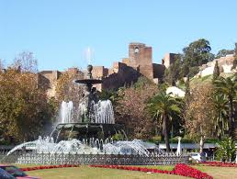
MALAGA
Approximately 1 hour by car

Follow either the AP7 of A7 towards Malaga. Follow the signs towards the city centre. Alternatively you can reach Malaga by train, the nearest train station is in Fuengirola that takes you directly into the city. There are regular buses that run to and from Fuengirola should you not have a car or wish to drive.

There is plenty to see and do in Malaga, you can choose to explore the city either by bike, or a fun guided segway tour or open top bus. The main shopping area is Calle Larios and from here you can explore the narrow twisting streets to the beautiful Cathedral and interesting shops and tearooms. Other areas of particular interest are The Picasso Museum, Alcazaba the best-preserved Moorish fortress in Spain and the new contemporary marina, which has numerous restaurants and bars.

MARBELLA
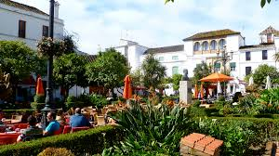
Approximately 25 mins by car. Park up then walk to the beautiful Orange Square in the Old Town or beachfront in 10 mins.

Marbella is one of the ritziest resorts on the Costa del Sol and the playground of the rich and famous.

The town's attractions include a thriving commercial centre, the coastal promenade where you can now walk to Puerto Banus and beyond or hire bikes, lovely beaches, yacht harbour and the Old Town.

A must see is the 'Plaza de Los Naranjos' (Orange Square) in the Old Town. Cross over the main road from the beachside to find the picturesque maze of streets, pretty squares and whitewashed buildings. A delightful area to browse the many interesting shops, enjoy a fabulous drink and meal al fresco in a vibrant atmosphere.

If you still have some Euros left, there is also a large indoor commercial centre 'La Canada' approximately 10 minute drive away. Here you will find numerous high street shops and restaurants.

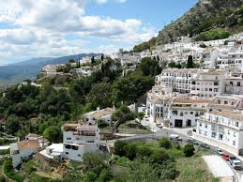
MIJAS
Approximately 30 minutes by car

Follow the AP7 toll road towards Malaga, through the tollbooths and take the exit road signposted Mijas. You

will arrive at a traffic island; follow the signs that make a left turn towards Mijas. You remain on this road all the way and it is a windy mountain road.

With its attractive mountain setting, picturesque little streets and white washed houses, Mijas is a popular excursion from the coast.

While obviously catering to tourists, Mijas has still retained much of it traditional Spanish charm. It has breath taking views of the surrounding mountains and amazing sea views probably the best on the coast.

PUERTO BANUS
Approximately 15 minutes by car

Follow the A7 towards Malaga, taking the road signposted for Puerto Banus. There is plenty of underground parking if you are travelling by car, or you can go by bus, or if you fancy seeing the coast from a different view you can take a boat from Marbella marina to Puerto Banus Port.

The dazzling marina of Puerto Banus with its luxury yachts, trendy restaurants and bars is a magnet for visitors to the Costa del Sol.

Around the Port are cafes, bars, restaurants and a string of luxury boutiques featuring every designer you could wish for. While restaurants along the quayside are the place to be seen, you will sometimes get better value from the small restaurants tucked away up flights of stairs in the back streets. A great place for people watching and spotting celebrities.

At night the Port comes alive and the smart restaurants, bars and clubs are filled with people all having a fabulous time.
On Saturday there is street market, which is located near the bullring in Nueva Andalucía a short stroll from the Port. The market gets very busy and it starts early in the morning until 2pm.

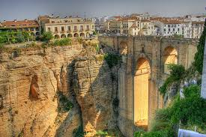
RONDA – PERSONAL FAVOURITE!!!
Approximately 45 minutes by car

From the main San Pedro roundabout on the A7 you will see signs for Ronda. This is a straight road up the mountain, all the way to the town.

Ronda is renowned for its spectacular setting, Moorish influence and the oldest bullring in Spain, built in 1785.

The beautiful town has wonderful shops and restaurants, all serving excellent Spanish cuisine.

SEVILLE
Approximately 2.5 hours by car

Take the A7 towards Algeciras/Cadiz until you see the signs for Seville. Follow these all the way.

Seville generates a style of romance all of its own. Andalusia's capital and most fashionable city, it is home to great art and magnificent monuments, as well as streets filled with restaurants and bars. The minaret tower of La Giralda and the great Cathedral it adjoins dominates it.

Seville is a city best to explore on foot and the Cathedral is a good starting point. The medieval quarter of Barrio de Santa Cruz nearby is a delightful maze of narrow streets and whitewashed houses adorned with wrought iron balconies, decked with flowers.

The royal palaces of Seville are a marvel. The centrepiece is the Palace Mudejar del Rey Don Pedro and is a superb example of Mudejar art.

If you have children the theme park Isla Magica is well worth a visit. The park was constructed on the former grounds of the Expo 92 World's Fair and opened in 1997. Opening times do vary and depend on the time of year so it is best to check.

MAPS

Estepona

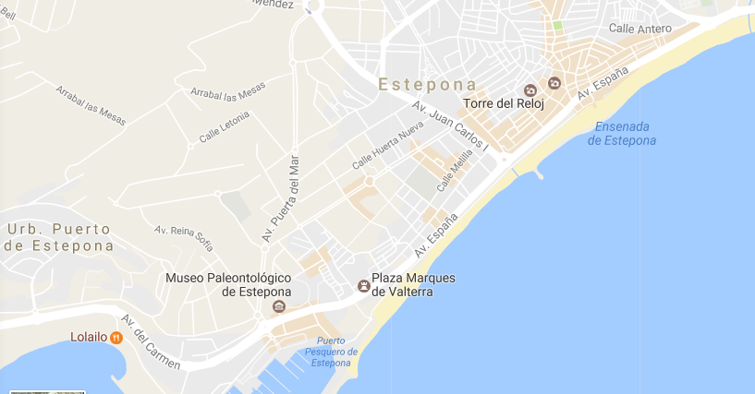
Old Town
PORT

